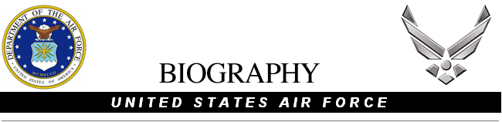

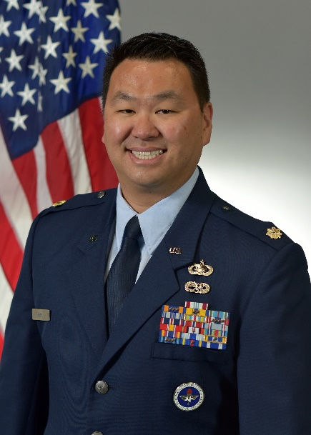
MAJOR KEVIN J.S. KIM
Major Kevin J.S. Kim is the Assistant Professor of the Air Force Reserved Officer Training Corps, Detachment 040, Loyola Marymount University in Los Angeles, California. He is responsible for recruiting, educating, and inspiring cadets at LMU and surrounding “cross-town” colleges, and then sourcing the Department of the Air Force with its next generation of high caliber officers.
Major Kim was born in Seoul, South Korea moved to the United States at six years old and grew up in Santa Clarita, California. He enlisted in the
Air Force in 2003 and started his career as an F-15 Avionics Systems Apprentice. He was selected for the Leaders Encouraging Airman Development (LEAD) program and earned his commission from the
United States Air Force Academy in 2010. He is now an intelligence
officer with a background in Distributed Common Ground System, National Tactical Integration, and Tactical Analysis Support Element activities. Prior to his current assignment, Major Kim served as the Duty Director of Intelligence in the Joint Operations Center-North American Aerospace Defense Command and United States Northern Command, Peterson Space Force Base, Colorado.

Major Kim has two deployments. His first deployment was to Afghanistan as a Tactical Systems Operator supporting Operations Enduring Freedom. Major Kim’s second deployment was to the Kingdom of Saudi Arabia as an Intelligence Exchange Officer. His duties included being the senior United States intelligence representative, establishing bilateral relationships, advising Intelligence, Surveillance, Reconnaissance capabilities for current operations, and orchestrating high level United States and Royal Saudi Air Force meetings.

EDUCATION
2006 United States Air Force Academy Preparatory School, United States Air Force Academy, CO
2010 United States Air Force Academy, United States Air Force Academy, CO
2010 Air and Space Basic Course, Maxwell AFB, AL
2015 Squadron Officer School, Maxwell AFB, AL
2021 Air Command and Staff College – Distance Learning, Maxwell AFB, AL

ASSIGNMENTS
1. June 2005 – May 2006, Student, United States Air Force Academy Preparatory School, United States Air Force Academy, CO
2. June 2006 – May 2010, Student, United States Air Force Academy, United States Air Force Academy, CO
3. July 2010 – August 2010, Student, Air and Space Basic Course, Maxwell AFB, AL
4. August 2010 – November 2011, Student, Intelligence Training Course, 315th Training Squadron, Goodfellow AFB, TX
5. November 2011 – March 2014, Mission Operations Commander, 8th Intelligence Squadron, Hickam AFB, HI
6. March 14 – November 2015, Flight Commander, 392nd Intelligence Squadron, Hickam AFB, HI
7. November 2015 – December 2015, Student, Squadron Officer School, Maxwell AFB, AL
8. December 2015 – February 2018, Flight Commander, 526th Intelligence Squadron, Nellis AFB, NV
9. February 2018 – December 2019, Director, Plans and Programs, 365th Intelligence, Surveillance, Reconnaissance Group, Nellis AFB, NV
10. December 2019 – December 2020, Chief, Target Intelligence Production, NORAD/NORTHCOM J23, Peterson SFB, CO
11. December 2020 – February 2022, Deputy Branch Chief/China Team Lead, NORAD/NORTHCOM J22, Peterson SFB, CO
12. February 2022 – June 2023, Duty Director of Intelligence, NORAD/NORTHCOM JIOC-North, Peterson SFB, CO
13. June 2023 – Present, Assistant Professor Aerospace Studies, Air Force ROTC Detachment 040, Loyola Marymount University, CA

MAJOR AWARDS AND DECORATIONS
Defense Meritorious Service Medal
Air Medal with three oak leaf cluster
Air Force Commendation Medal with two oak leaf cluster
Joint Service Achievement Medal
Air and Space Achievement Medal

EFFECTIVE DATES OF PROMOTION
Airman Basic Nov 10, 2003
Airman May 10, 2004
Airman First Class Mar 10, 2005
Second Lieutenant May 26, 2010
First Lieutenant May 26, 2012
Captain May 26, 2014
Major Mar 01, 2020

(Current as of July 2023)

